Sky Tech Center 9/14/15
Due THURSDAY, September 17th, 2015

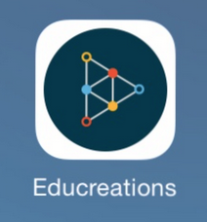

This week’s center focuses on foundation and building. During your unit time on Wednesday, you will be constructing something (your Sky teachers will tell you about that project.)

For the center assignment, you will need to use the app Educreation on the iPads. A set of iPads will be available by the Tech turn in bin in room 200. To find the app, you can search for it by pulling down on the home screen or you could go to the “Presentation” folder.

If you need to log into Educrations from the iPad, the username is andrea@wingraschool.org and the password is duck1972.
Make sure you are logged in; otherwise you can’t share or save multiple drafts. You know because it should say “Andrea’s Lessons” on top and you can see a lot of videos about Hawaii. You do not have to log out when you’re done.

The one major downfall of Educreations is that if you are recording and you want to erase or go back to try again, you can’t. It is a huge bummer. Therefore, you need to either roll with it and continue on or start over.

Your task:
During and/or after you finish constructing your unit building on Wednesday, use Educreations to record your voice or text about why you built it the way that you did. I want to hear details about your thought process and reasoning. Describe your foundation. Describe what you would do differently next time. Describe what worked well.

Take pictures of your structure using the camera on the iPad. Insert these pictures into your lesson so I can see what you are talking about.
After you’ve recorded your lesson, use the symbol in the top left corner to go back. You will be prompted to name your video.
Please include your group members’ names in this title.

You do not have to share it with me because as soon as it is saved, it goes into a community zone and I can see it from there.

On that note, please do not delete anything from a Hawaii project that I had the little kids do last year. Thanks.

I recommend that on Tuesday, you use the app and play with it so you are comfortable for Wednesday.

I will not be available to help you on Wednesday.
I am available on Tuesday afternoons! Come see me in the Tech lab!

Create a new “lesson” by using the plus sign in the top left corner.
- How do you add or change slides?
- How do you add color?
- How do you add pictures?
- How do you erase drawings or pictures?
- How do you add text?
- How do you record?
- How do you delete audio? Trick question! You can’t.
- How do you delete your lesson and start over? Not a trick question. You can.
- What happens when you push the record button? What does it record?
- Can you get pictures on before you record? (I’d recommend it!)

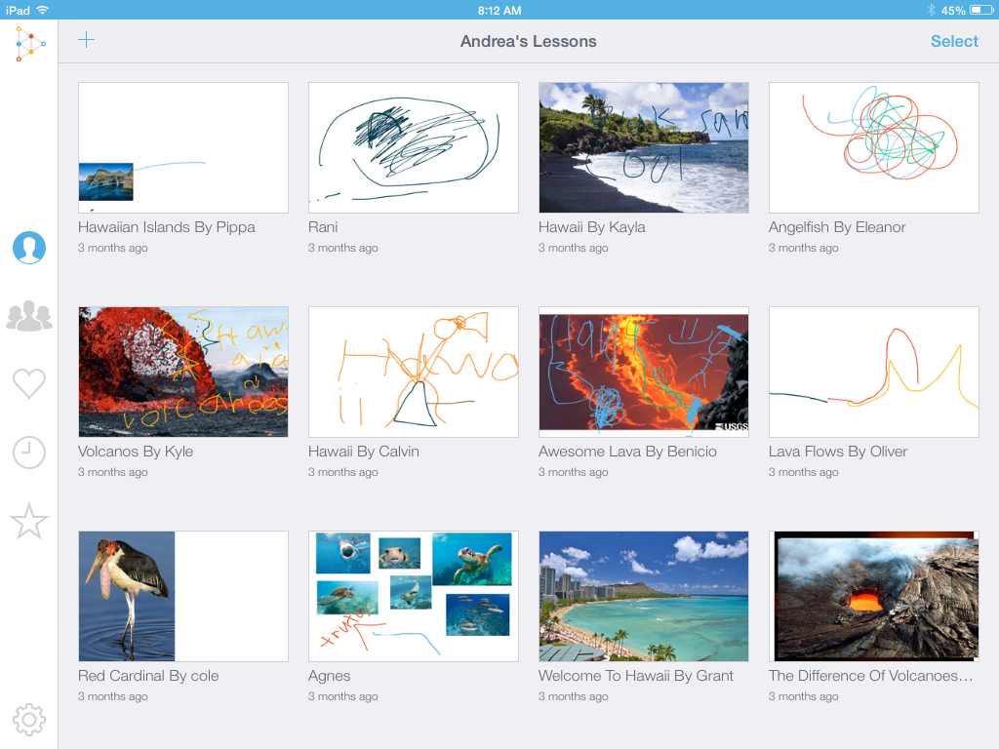
This is a screenshot of the home page. You can tell that I’m logged in. Do you see the plus sign? That’s how you start.
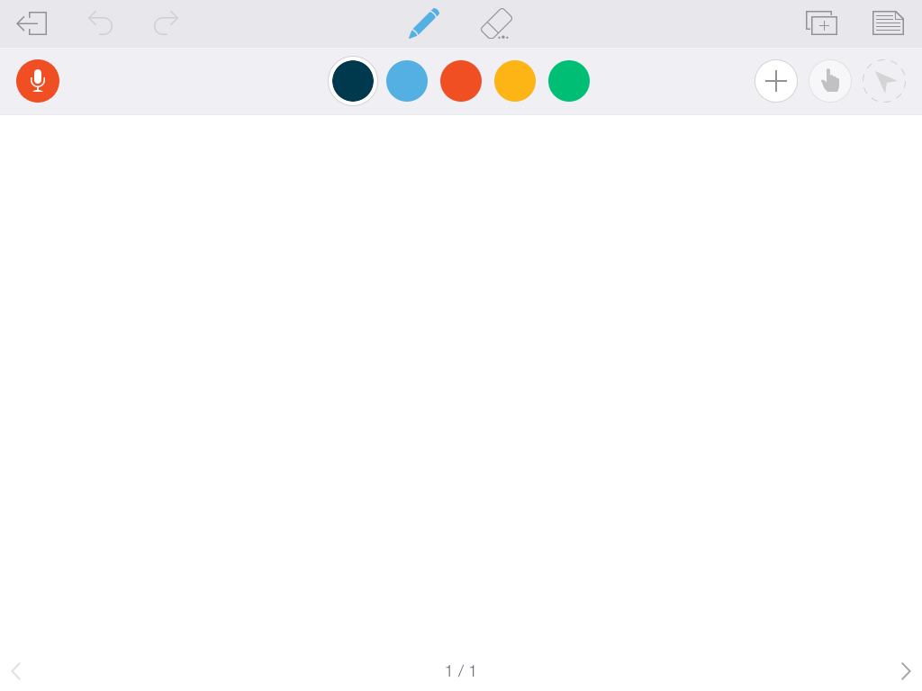
This is the screen that shows up after you start. Don’t know what something does? Tap it to find out! You can undo your actions.

